Highcliffe School Student Bulletin
Monday 19th – Friday 23rd November 2007: Week A

Thought For The Week:
"Aerodynamically the bumblebee shouldn't be able to fly,
but the bumblebee doesn't know that so it goes on flying anyway."
- Mary Kay Ash

News Story of the Week:
Older kids to help beat bullies
See http://news.bbc.co.uk/cbbcnews/hi/uk/default.stm
for more details and other news stories!


Bring & Buy Sale: A very big thank you to everyone who supported Year 7’s Children in Need Bring and Buy sale. We raised £146.97!

Also, all the Perfect Day DVD's have now been sold - Thank you for your support!



19th – 23rd November is Anti Bullying Week. Please be aware of activities around school http://www.anti-bullyingalliance.org.uk

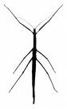

Paint a box and meet the stick insects! Eco Club will meet after School on Tuesday 20th November to paint paper recycling boxes. 3.30pm - 4.15pm in Sc6 (Note change in finish time due to dark evenings). Come along and help save those recycling boxes from the skip!!!


The Yellow pages recycling competition has begun...
As the new yellow pages are delivered the old ones face the bin...but STOP! Before you recycle it rip off the front cover and bring it into school. The more covers we get the more chance we have of winning, 8 schools in Christchurch are taking part and we want to win the HUGE CASH PRIZE! and SAVE PAPER FROM LANDFILL
Ask friends and family for theirs, bring in old yellow pages covers to your tutor (not 2007/8) covers
Do YOUR bit to help the environment!

Come along to the new club: "Stitched Up”: AT7 Tuesday lunchtimes at 1.30pm. New items made from recycled materials!

SPORTS RESULTS
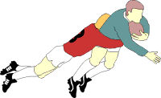
U15 girls football v Bucklers Mead - lost 0-2
Year 8 rugby tournament - 1st place
Year 7 netball v BSG - lost 0-1
Year 11 netball v BSG - won 12-7
Year 9 rugby tournament - 1st place

This new website is free to join:
http://www.dothegreenthing.com/
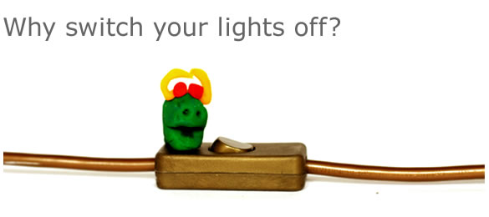
WHAT??? Every month members make a difference to help in the fight against global warming. This month the theme is 'do it in the dark'. It takes seconds to sign up, you can then post your contributions and at the end of the month you will be informed of how much carbon dioxide has been saved from release into our atmosphere.

HOW??? Do it in the dark! Why watch the TV with the lights on? Try writing in the dark, dressing in the dark (watch you don't trip over, though!). Turn the lights off and have a little think...

DID YOU KNOW? If all the electricity we used was generated from clean, natural sources like solar panels or wind turbines there wouldn't be a problem. But most electricity in countries like the UK or the US comes from big power stations burning coal or gas. This pumps enormous quantities of CO2 into the atmosphere, which contributes to climate change.

SO DO YOUR BIT...If we could all use less electricity simply by switching off things like lights when we're not even using them we'd save a lot of CO2 and a lot of money too. In the UK we waste £140 million worth of electricity every year by leaving lights on we don't need

Do YOUR bit and sign up now!

MUSIC NOTICES
Music clubs this week:
Shout! - vocal group for Years 7-9 - Monday lunchtime 1.40pm in EX3
Guitar Club - for guitar players of all abilities - Tuesday lunchtime 1.40pm in EX2
Vocalis - Vocal group for years 10 and above - Wednesday lunchtime 1.40pm in EX3
Harmonious Funk Jazz Band - for all wind instruments - Wednesday 3.00pm-5.00pm in EX3
Music Theory Club - Thursday lunchtime 1.40pm in EX3

BRAIN TEASER

What is the number missing from the following sequence?
By figuring out the relationship of these watch settings to one another, you should be able to determine what time will show up on Watch E.
WATCH A 5:23
WATCH B 8:26
WATCH C 12:30
WATCH D 5:35
WATCH E ______
Entries to be put in the Brainteaser box in Ma6 with name and tutor group before Friday 15th November.

The solution to last weeks brainteaser was:
The largest number was 66 (LXVI)
The smallest number was 44 (XLIV)

P.E. FIXTURES/PRACTICES

19th – 23rd NOVEMBER 2007

 | LUNCHTIME | AFTER SCHOOL
Monday | Year 7 basketball
Tuesday | Year 9 basketball | Years 9,10,11 dance club  Years 7 & 8 girls football club  Years 7 & 9 football club  Year 10 football club
Wednesday | Year 8 basketball | Year 10 football v Purbeck (A)  Girls rugby club  Years 7 & 8 netball club  Years 9,10,11 girls football club  Year 7 basketball club
Thursday | Years 10/11 basketball | Year 11 netball v Ballard (A)  Years 9 & 10 netball club  Years 7 & 8 dance club  Years 10 & 11 basketball club
Friday | Years 10/11 girls basketball

